**CHE517 ADVANCED PROCESS CONTROL**

**FINAL EXAM**

Professor Shi-Shang Jang Jan. 12, 2011

**Problem #1 (20%)**

In the distillation of below, the flows of reflux and steam to the reboiler are manipulated to control the distillate and bottoms product purities. Open loop step tests on each of these manipulated variables result in the following transfer functions

$$Y_{D}=-3\left(\frac{1-0.11s}{1+0.35s}\right)M_{R}\left(s\right)+\left(\frac{0.75}{1+0.35s}\right)M_{s}\left(s\right)$$

$$X_{B}\left(s\right)=\left(\frac{2.5}{1+0.35s}\right)M_{R}-3.5\left(\frac{1+0.25s}{1+0.35s}\right)M_{s}\left(s\right)$$

Where YD(s) is the composition of the heavy key in the distillate, XB(s) is that of the light key in the bottoms, in %TO, and MR(s) and MS(s) are the signals to the reflux and steam valves, respectively, in %CO. The time parameters are in hours.

1. Calculate the relative gains for this system and determine the correct way to pair the controlled and manipulated variables. Do the loops help or fight each other?
2. Draw the block diagram and design the decouplers for this system. Briefly discuss any implementation problems and suggest modifications to ensure the

control system is stable.

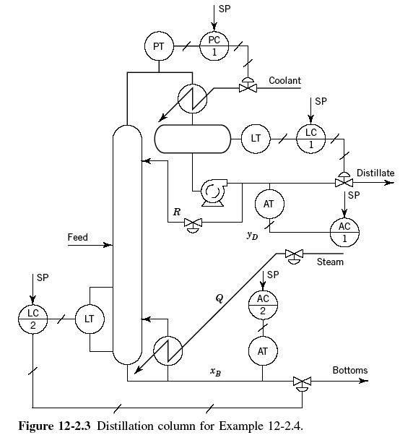

**Problem #2 (20%)**

Consider the following multivariable plant



1. Consider the following matrix



Calculate the relative gain for the system, is there a good pairing strategy for the 2×2 system?

1. Design a decoupler:



find the analytical solution for D.

**Problem #3 (20%)**

Consider the jacketed continuous stirred tank reactor (CSTR) sketched in the following Figure. The following information is obtained from testing the reactor and its control system: The transfer function of the reactor temperature to the jacket temperature is first-order lag with a gain of 0.6。C/。C and a time constant of 13 min. The transfer function of the jacket temperature to the coolant flow is a first lag with a gain of -2.0。C/(kg/s) and a time constant of 2.5 min. The control valve is linear with constant pressure drop and is sized to pass 12 kg/s when folly opened. Its time constant is negligible. The jacket temperature transmitter is calibrated for a range of 0 to 100。C, and its time constant is negligible.

1. Decide on the proper fail position of the control valve loop. Draw the block diagram showing all transfer functions and write the closed-loop transfer function of reactor temperature to its set point. Pay particular attention to the signs which must correspond to the fail position of the valve and the controller action.
2. Write the characteristic equation for the single feedback loop and calculate its ultimate gain and period by direct substitution.
3. Design a cascade control system for the reactor temperature with the jacket temperature as the intermediate process variable, specifying the action of both controllers. Draw the complete block diagram for the cascade control system showing all transfer function and their signs. 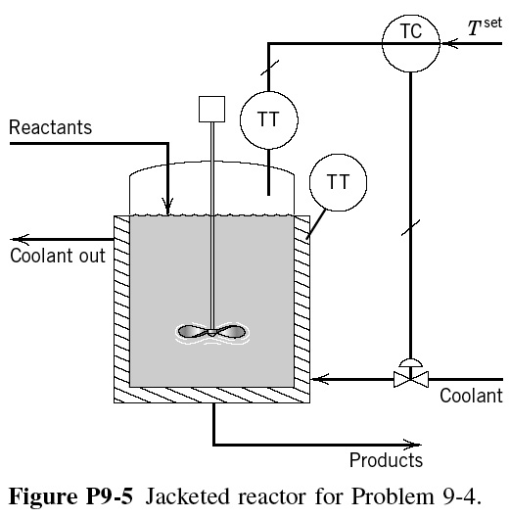

**Problem #4 (20%)**

Derive a pulse transfer function (z-domain) for the following plants with a zero order hold and a sampling time of 1:

1.  (7 points)
2.  (7 points)
3.  (6 points)

**Problem #4 (20%)**

A cascade control configuration is sometimes used to separate different objectives of feedback control. For instance, first an inner loop can be used to stabilize the process, and then an outer loop can be used to control the output to track set-point changes and reject disturbances. An example of a cascade control system is shown in the following figure. The process transfer function



is unstable.

1. Determine the maximum range of *Kc2* values for which the inner loop will be stable.
2. Now assume *Kc2*=6 and *Gc1* is a PI controller with gain *Kc1* and τ*I*. Find the values of *Kc1* and τ*I* such that the closed-loop poles of the transfer function from *Ysp* to *Y(s)* are at s=-0.5±0.2j.

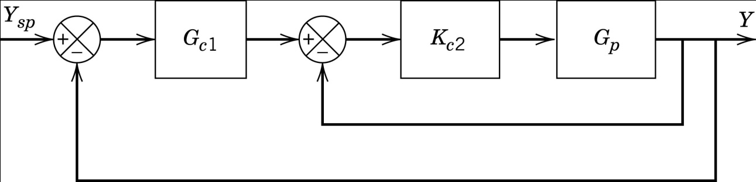

**Problem #5 (20%) Take home**

Consider the following plant transfer functions:



1. Find frequency responses for the above plants.
2. Make Bode and Nyquist plots using the results of (i).
3. Find the ultimate gains and ultimate frequencies of the above plants.
4. SIMULINK the closed loop performance using a PID controller and a setting based on (iii)
5. Assume that the plant real transfer function is unknown, approximate the plant transfer function using a reaction curve.
6. Tune a PID controller using (v) and compare the closed loop performance with (iv) using SIMULINK.
7. Derive a Smith predictor using the result of (v), compare the closed loop performance with (iv) and (vi) using SIMULINK.